FEBRUARY /febjułeri/- LUTY

Numbers- cyfry
Wiggle /łigyl/- poruszać, kiwać
sad- smutny
happy- wesoły
scared /skert/- przestraszony
angry- zły
sleepy- śpiący

The song: ‘Wiggle fingers!’
Show me your fingers, one, two, three, four, five.
Show me your fingers, wiggle them, wiggle them!
Show me your fingers, one, two, three, four, five.
Show me your fingers, wiggle them, wiggle them!
One, two, three, four, five!
The rhyme: ‘How many?’

One cake. Sad baby.
Two balloons. Sad baby.
Three hats. Sad baby.
Four friends. Sad baby.
Five presents. Happy baby!
Happy birthday, baby!
Polecane piosenki:
https://www.youtube.com/watch?v=DR-cfDsHCGA – liczymy od 1-10
https://www.youtube.com/watch?v=D0Ajq682yrA – liczymy od 1-20
https://www.youtube.com/watch?v=MMCBFCrZcdg – liczymy z robotem od 1-10
https://www.youtube.com/watch?v=TdDypyS_5zE – liczymy misie do 10
https://www.youtube.com/watch?v=l4WNrvVjiTw – śpiewamy o emocjach

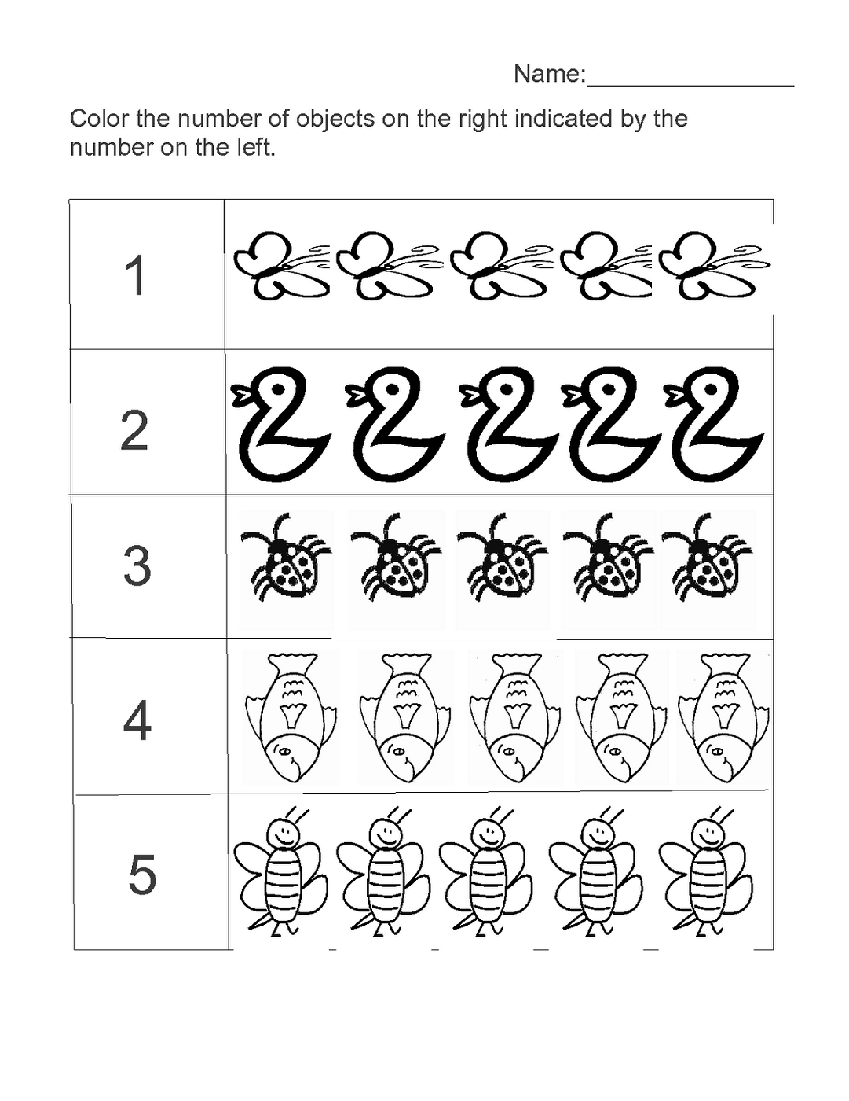
Źródło strony: https://grottepastenaecollepardo.org/

