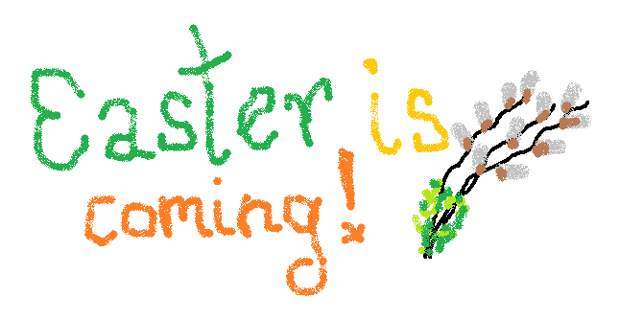
Easter is coming!- zbliża się Wielkanoc!
basket- koszyk
chicken- kurczak
chick- kurczaczek
bunny- króliczek
sheep- owieczka

Song- piosenka
Fluffy bunny, fluffy bunny
Fluffy chick, fluffy chick
Jump into the basket, quick, quick!

Fluffy bunny, fluffy bunny
Fluffy chick, fluffy chick
Jump into the basket, quick, quick!

Easter Bunny:
Easter bunny, jump, jump, jump
Easter bunny, stamp, stamp, stamp,
Easter bunny, run ,run, run,
Easter bunny have some fun!

fluffy- puchaty
soft- miękki
long ears- długie uszy
small tail- mały ogonek
pick up the egg- podnosić jajko
look for the eggs- szukać jajek

Polecane piosenki i materiały: https://www.youtube.com/watch?v=hb9tt7LiYrc (easter song)
https://www.youtube.com/watch?v=i-Z7GQDu0xE (wielkanocne opowiadanie w języku angielskim)
https://www.youtube.com/watch?v=Y2tt_4lMxYs
https://www.youtube.com/watch?v=85iD8QA9X_M

Easter Bunny
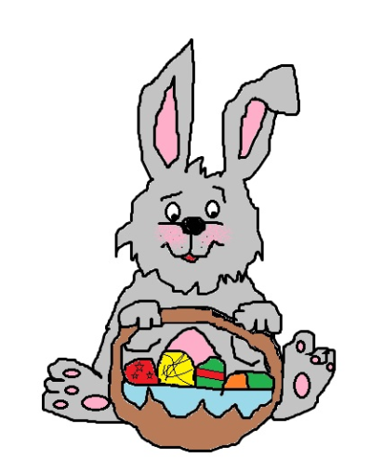 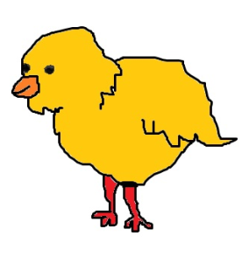Chick
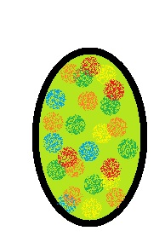 Easter eggs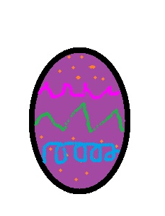
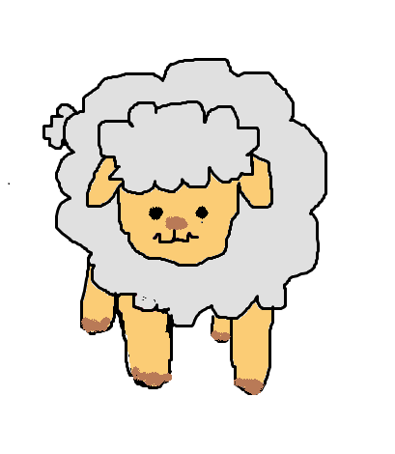 Sheep
autor obrazków: Aleksandra Nyk

